Interactive Content in Marketing Communications

Huminskaya L.D.

Belarusian State University of Informatics and Radioelectronics

Minsk, Republic of Belarus

Bulauskaya T.V. – Senior Lecturer

This paper deals with the definition of interactive content, its benefits and disadvantages. The paper also describes which types of interactive content exist and shows diagrams of users’ preferences towards interactive content in social media.

With the development of digital marketing, to acquire new customers and retain them, an online business needs to create unique content that will stand out amongst the competitors.

Interactive content is any type of material that conveys its message by encouraging user participation [1]. In contrast to static content, which is consumed by reading or watching only, e.g. articles or videos, interactive content considers users’ engagement. The most common types are interactive calculators, polls, quizzes, giveaways and contests, challenges etc. [2]

According to the results of a survey conducted in social media, interaction with other users and content consumption is the most important feature of social media to people related to marketing. Meanwhile, people, who are not related to marketing, choose social media based on its popularity, as depicted in Figure 1.

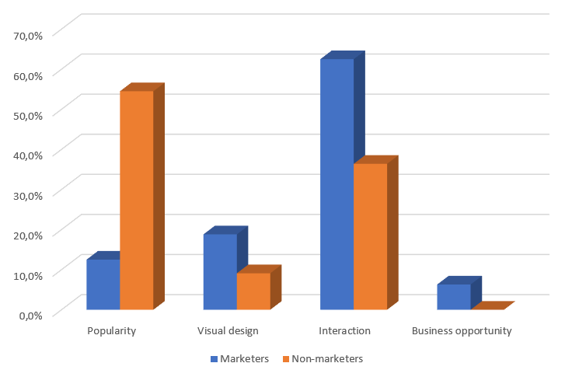

Figure 1 – The main reason to use social media according to marketers and non-marketers

People value interaction and fun content the most. Interactive content helps users to be engaged in various activities from meeting new people and sharing interests with them to running a business and attracting audience. Interactive content became a useful tool for marketers to run promotional campaigns.

The NBA Instagram poll can serve as an example of interactive content. In each round of games, the page posts a poll on which team will win, which encourages fans to cheer for their favorite team [3]. Mortgage Calculator by NerdWallet finance company is designed to estimate monthly house payment, which raises brand awareness and facilitates customer acquisition [4].

The main benefit of interactive content is combining information and entertainment: aside from learning about a brand, consumers are involved in the content by certain triggers holding their attention. For example, Disney creates quizzes about their movies to test the audience’s knowledge. Another advantage is increased engagement rates. Because users actively interact with a brand’s content, it leads to brand promotion to a wider audience. Interactive content contributes to creating a community around a brand.

A possible drawback of interactive content is added costs and resource requirements. Using sophisticated tools and hiring skilled workers is essential in marketing today. Another disadvantage is that interactive content with its complex algorithm might slow down a website or even be not compatible with certain browsers or devices. Businesses need to consider all factors before starting to make interactive content.

In conclusion, it should be stated that interactive content is an effective tool that can be broadly used in marketing. Interactive content combines what consumers need – fun content – and what a brand needs – informing customers about the company.

**References:**

1. *Interactive Content Guide: How to Bring Life to Your Content Marketing Strategy [Electronic resource]. – Mode of access:* [*https://rockcontent.com/blog/what-is-interactive-content/#:~:text=Interactive%20content%20is%20any%20type,%2C%20videos%2C%20and%20animated%20infographics*](https://rockcontent.com/blog/what-is-interactive-content/#:~:text=Interactive%20content%20is%20any%20type,%2C%20videos%2C%20and%20animated%20infographics)*. – Date of access: 26.03.2023.*
2. *10 Interactive Post Ideas You Need to Use on Social Media [Electronic resource]. – Mode of access:* [*https://socialbee.com/blog/interactive-post-ideas/#pp-toc__heading-anchor-6*](https://socialbee.com/blog/interactive-post-ideas/#pp-toc__heading-anchor-6)*. – Date of access: 26.03.2023.*
3. *Instagram [Electronic resource]. – Mode of access:* [*https://www.instagram.com/nba/*](https://www.instagram.com/nba/)*. – Date of access: 26.03.2023.*
4. *Mortgage calculator [Electronic resource]. – Mode of access:* [*https://www.nerdwallet.com/mortgages/mortgage-calculator*](https://www.nerdwallet.com/mortgages/mortgage-calculator)*. – Date of access: 26.03.2023.*